Q-8-3
Correct answers marked with an asterisk (*)

1) As part of a study, twenty students rated their own attractiveness on a scale from 1 – 10, and had a picture taken. In the second part of the study, a group of 79 college student volunteers (not part of the original group of 20) rated the attractiveness of each of the 20 students in the pictures on a scale of 1 – 10. Researchers averaged the attractiveness rating of the 79 "raters" (referred to as the societal rating) to compare to the self-rating to determine whether or not college students are accurate in their self-perceptions. Summary statistics are presented in the following table. The average difference in attractiveness ratings (self – societal) in the sample was 1.066 with a standard deviation of 1.507. A dotplot of these differences follows.
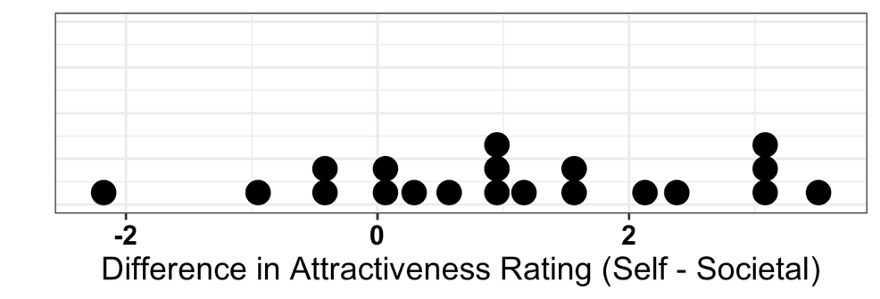
Would a theoretical approach be valid to analyze these data?
a. Yes, since the sample size of 79 is at least 20, and the distribution of differences is not strongly skewed.
b. Yes, since the sample size of 40 is at least 20, and the distribution of differences is not strongly skewed.
*c. Yes, since the sample size of 20 is at least 20, and the distribution of differences is not strongly skewed.
d. No, a theoretical approach would not be valid because the sample size is too small.

2) As part of a study, twenty students rated their own attractiveness on a scale from 1 – 10, and had a picture taken. In the second part of the study, a group of 79 college student volunteers (not part of the original group of 20) rated the attractiveness of each of the 20 students in the pictures on a scale of 1 – 10. Researchers averaged the attractiveness rating of the 79 "raters" (referred to as the societal rating) to compare to the self-rating to determine whether or not college students are accurate in their self-perceptions. Summary statistics are presented in the following table. The average difference in attractiveness ratings (self – societal) in the sample was 1.066 with a standard deviation of 1.507.
Calculate the standard error of the sample mean difference in attractiveness ratings (self – societal).
a. 1.066
b. 3.163
c. 1.507
*d. 0.337

3) As part of a study, twenty students rated their own attractiveness on a scale from 1 – 10, and had a picture taken. In the second part of the study, a group of 79 college student volunteers (not part of the original group of 20) rated the attractiveness of each of the 20 students in the pictures on a scale of 1 – 10. Researchers averaged the attractiveness rating of the 79 "raters" (referred to as the societal rating) to compare to the self-rating to determine whether or not college students are accurate in their self-perceptions. Summary statistics are presented in the following table. The average difference in attractiveness ratings (self – societal) in the sample was 1.066 with a standard deviation of 1.507.
Based on the standardized statistic for this scenario, what is the conclusion?
*a. Strong evidence exists that students similar to those in the study are not accurate in their self-perception of attractiveness, on average.
b. Strong evidence exists that students similar to those in the study are not accurate in their self-perception of attractiveness, on average.
c. Strong evidence exists that students similar to those in the study are accurate in their self-perception of attractiveness, on average.
d. No evidence exists that students similar to those in the study are not accurate in their self-perception of attractiveness, on average.

4) Researchers randomly selected 36 children who had been identified as gifted from a large city. The IQ of each child and the IQ of the child's mother were measured. A statistical analysis will be performed to determine if IQs of gifted children tend to be higher than their mothers' IQ on average. The mean difference in IQ (child – mother) was 3.22 points, with a standard deviation of 7.41 points.
The p-value for these data is 0.0067. Would the results of this study be considered statistically significant at the 5% significance level? Select one.
a. Yes, because random sampling was used.
b. No, because groups were not randomly assigned.
*c. Yes, because the p-value is less than 0.05.
d. No, because the validity conditions were not met.

